Aquifer Resource Innovators
(ARI)
Consultants:
Project Manager: Katie Tritsch
Asst. Project Manager/ Webmaster: Eric Schroeder
GIS Analyst: Katie Steele
GIS Analyst: Kevin Taylor

December 10, 2012
Mapping and Analysis of Wastewater Spills in the Barton Springs and Southern Segments of the Edwards Aquifer

Prepared by: Aquifer Resource Innovators (ARI)
Prepared for: Greater Edwards Aquifer Alliance (GEAA)
ABSTRACT
This report details the process and results of the Aquifer Resource Innovators (ARI) project on mapping and analyzing wastewater spills within Hays, Travis, and Williamson counties. The project was done under the instruction of Dr. Yongmei Lu and the Executive Director of GEAA, Annalisa Peace. The purpose was to shed light on the amount of pollution which may be seeping into Edwards Aquifer, potentially spoiling the groundwater and sensitive ecosystem it supports. The project involved the use of ArcGIS to geocode spill locations and produce maps illustrating where they occurred within each county along with their volume amount. The project also included the creation of an interactive map in order to present findings to the public and raise awareness of impediments to aquifer health. ARI additionally attempted to look at underlying factors behind the causes and effects of wastewater spills in the region. The team found a correlation of wastewater spills to cities growing in population and infrastructure. They compiled statistics on the total amount of spills, gallon amounts, and occurrences within the recharge zone and contributing zone, as well as compiled data surrounding the reported causes for the spills. Many interesting conclusions were drawn from the processing and analysis of this data which is explained in detail throughout the entirety of this report.

Table of Contents
1. INTRODUCTION 1
1.1 BACKGROUND 1
1.2 PROBLEM STATEMENT 2
1.3 SCOPE 2
1.4 LITERATURE REVIEW 2
2. DATA 5
2.1 DATA COLLECTION 5
2.2 DATA PROCESSING 5
2.2.2 Aquifer zones 6
2.3 METHODOLOGY 7
2.3.1 Geocoding 7
2.2.2 Thematic static maps 7
2.2.3 Interactive mapping 8
3. RESULTS 10
3.2 QUALITATIVE ANALYSIS 11
3.3 DISCUSSION 12
4. CONCLUSIONS 13
5. REFERENCES 15

Appendix I: Maps
Appendix II: Metadata
Appendix III: Team contribution

1. INTRODUCTION

1.1 BACKGROUND

The Edwards Aquifer is a unique and special place to Central Texas. The aquifer serves nearly two million people in Central Texas with fresh water, which is used for agricultural, recreational, and personal purposes. It consists of four main zones: the contributing zone (CZ), recharge zone (RZ), transition zone, and the artesian zone. The RZ is the most sensitive part of the aquifer, where water from streams and rainfall directly enters the aquifer. As Central Texas grows in population, Edwards Aquifer is under increasing pressure from over-use and development. With this encroachment in and along the RZ, there is growing cause for concern regarding the future of the aquifer.
Pollution is a major threat to the aquifer system and its unique inhabitants. Pollution from point and non-point sources can seep into the porous limestone that characterizes the RZ of the aquifer and spoil this great natural resource. Wastewater spills make significant contributions to pollution levels in the groundwater, and can cause irreversible damage to the health of the aquifer and the people that consume its water.
Providing a Geographic Information System (GIS) will give the public and regulating authorities access to, and the ability to interface with, the wastewater spills in the Texas Commission on Environmental Quality (TCEQ) Region 11 of the Edwards Aquifer. The ability to visualize and interact with this information will aid in the understanding of the quantity and spatial distribution of wastewater spills in the different areas of Region 11. The findings of this project could potentially allow for increased regulation involving wastewater spills, which would aid in increasing the quality of public health as well as general water resources in the Edwards Aquifer.

1.2 PROBLEM STATEMENT

The purpose of our project was to map and analyze wastewater spills that occurred in TCEQ Region 11 within the last five years. The geovisualization of this data is expected to enhance GEAA’s understanding of the spatial distribution, gallon amount, frequency, and causes of wastewater spills that may be a hazard to aquifer health. Additionally, the interactive mapping portion of the project was aimed at enhancing the public’s understanding and concern for wastewater spills that may affect their health by polluting groundwater reserves.

1.3 SCOPE

Our project was focused on wastewater spill data within the last five years occurring within the RZ and CZ of the Southern and Barton Springs Segments of the Edwards Aquifer Region 11. The total area of Region 11 is comprised of ten counties, however due to a priority list provided in the Request for Proposal, we began with Travis and Hays County. We ended up adding Williamson County due to the significant area of RZ and CZ lying in its boundaries. Figure 1 illustrates the counties and aquifer zones used in our analysis.

1.4 LITERATURE REVIEW

GeoTex Environmental Solutions was a GIS4427 team in Spring 2012 that did a similar project involving wastewater spills in South Central Texas. Specifically, GeoTex focused on TCEQ Region 13 which includes: Travis, Hays, Comal, Bexar, Medina, Uvalde, and Kinney counties. They focused on spills which occurred in the RZ within the time frame January 2004- May 2012. GeoTex spent the majority of their 10-week project span collecting spill records from Municipal Utility Districts (MUDs) and other wastewater service providers or regulators. Because of this, we decided to limit data collection solely from TCEQ. This gave us more time to focus on our interactive mapping, different types of static maps, and qualitative analysis of our findings. GeoTex recently did a press conference with the City of San Antonio through GEAA to present and discuss the results of their project. Our project was mentioned during the press conference as well, and we hope the completion of this project allows us to provide further information about the wastewater spills within Region 11.
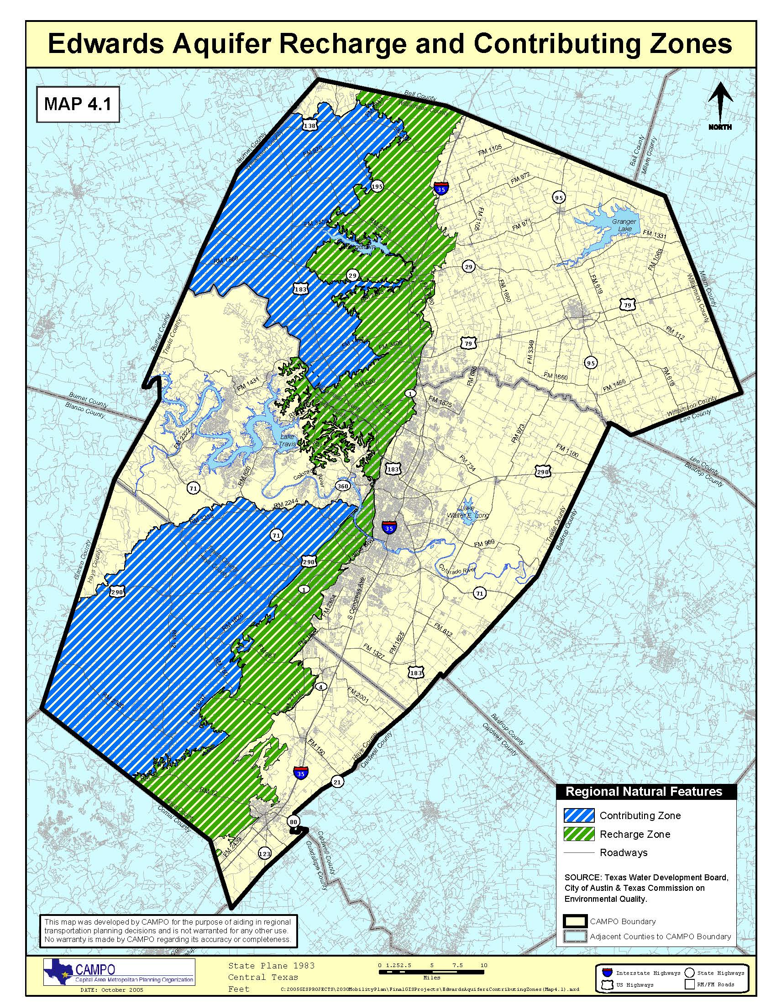
Figure 1. Scope of our project.
Source: http://www.campotexas.org/pdfs/Map4-1.pdf

2. DATA
2.1 DATA COLLECTION
The wastewater spill data collected for this project was an excel table provided by TCEQ containing all ten counties within Region 11. The table conveyed the date, location, cause of spill, and action taken to remedy the spill. This table had to be reduced to only the wastewater spills in Travis, Hays, and Williamson counties. The new table had to be cleaned up in order to appear more user friendly and for ArcGIS to geocode the addresses.
The rest of the data we used was basic shapefiles (.shp), easily downloadable from various state websites. The roads layer is from the Texas State Data Center (TSDC), the rivers layer is from the Texas Water Development Board (TWDB), the counties and cities layer are from Capital Area Council of Governments (CAPCOG), and the Edwards Aquifer zones are from TCEQ and TWDB. These shapefiles combined with the geocoded wastewater spills helped create a bigger picture of the RZ and CZ of Edwards Aquifer in Hays, Travis, and Williamson counties.

2.2 DATA PROCESSING
2.2.1 Wastewater spills
We received an Excel document from TCEQ containing over 1,800 wastewater spill records in Region 11. From that table we initially extracted the spills for Hays and Travis County, first by county and then by start date (2007-2012). We created new tables for both counties, and processed them by creating new columns of the full street address, city, state, zip code, spill cause and action taken for remediation. After the progress report we repeated the process for Williamson County. This was fairly time-consuming as much of the data contained long descriptions of the location, oftentimes without a city, and never containing a zip code. We used Google Maps and Google Earth to confirm each address location within the county. An example of our raw data can be seen below in Figure 2. 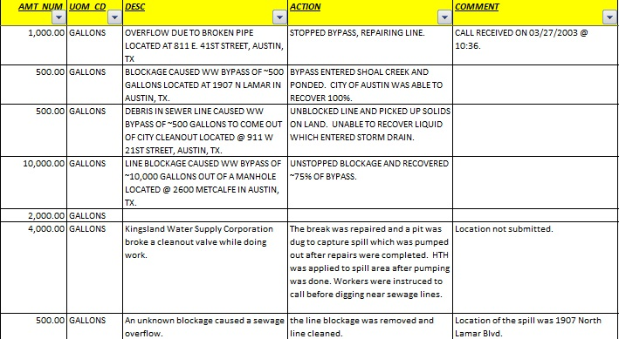
Figure 2. Example of raw spill data from TCEQ.
Figure 2. Example of raw data from TCEQ.

2.2.2 Aquifer zones
We found contradictory data regarding the Edwards Aquifer RZ and CZ depending on the source. Our original RZ and CZ shapefiles were downloaded from Edwards Aquifer Authority (EAA). Unfortunately this shapefile cut the zones off at the Hays County border. Because our scope extended north of EAA’s boundary, we had to find new aquifer shapefiles. We obtained two different ones; one from TCEQ and one from TWDB. By looking at different maps of the aquifer, we concluded the TCEQ aquifer layers illustrated their jurisdictional boundary, whereas the layer from TWDB illustrated the geological boundary of the aquifer. We used the ‘Merge’ function to combine the two layers in order to produce a single shapefile for both the RZ and CZ. The end result is identical to the zones seen in Figure 1.

2.3 METHODOLOGY

2.3.1 Geocoding
We ended up using the 10.0 North American Geocode Service provided in ArcMap 10.0 and input our spill records with only a full name, city, state, and zip code. Our geocoding results were impressively successful; after matching tied spills in the ‘Results’ window, we successfully matched 100% of spills in each county. This was due to: 1) some addresses only being matched by zip code, and 2) our removal of data received without any geographic information. The data loss for each county was rather significant. This is illustrated below in Table 1. For the points only matched by zip code in each dataset we went through the Attribute tables in order to find each point, queried the road or address given in the table, and opened an Editing session in order to place the spill in the correct spot.
Table 1. Data received and data mapped
County | Spill records received | Spill records mapped | Data loss (%)
Hays | 113 | 92 | 18.6
Travis | 422 | 345 | 18.2
Williamson | 105 | 98 | 6.7

2.2.2 Thematic static maps
Successful geocoding for each county was the predominant goal for our project. However our other static maps and analysis included other types of geoprocessing and data analysis. For our spill cause map we had to manually go back through the data tables and input a category each cause description fell under. We attempted to base our list on the most common causes in the table. These included:
- Electrical failure
- Blockage
- Human error
- Unknown
- Damaged pipe
- Infiltration & Inflow
- Mechanical failure
- Other
For our Travis sequential maps, we ‘Selected by Attributes’ start dates within each year, created a new layer from those spills, and made separate maps for each, with the spills growing upon each year. Our point density map was created using the ‘Point Density’ tool in ArcMap, with cell size set to 20 and without weighting based on spill volume. Our population density map included adding a new field to the attribute table and using the field calculator to determine the area of each census tract in order to divide the population by the area. Our Manifold and Google Earth maps necessitated a fair amount of data tweaking as well, mostly due to these programs functioning differently than ArcGIS. All maps mentioned above are located in Appendix I.

2.2.3 Interactive mapping
We used Manifold System 8.0 (64-bit) for our interactive mapping component. Most data processing for Manifold was done inside the program, mostly in editing the tables for readability and altering symbology of the layers. We also converted our shapefiles into Google Earth keyhole markup language (.kml) files, however due to lack of time we did not compile a map. The .kml files are included in the CD for potential further use by GEAA.

3. RESULTS
3.1 STATISTICAL FINDINGS
Table 2 provides an excellent summary of the findings for our project. With 534 spill records mapped over a five-year period, 17.4% were within the RZ and 13.6% within the CZ. A total of 12 million gallons of wastewater was spilled in this period, excluding all records which could be obtained from sources besides TCEQ. The largest spill we mapped was 1.8 million gallons. There are significant differences in frequency and gallon amount of wastewater spills within each county. For instance, Travis County had the largest gallon amount of combined spills by at least 2 million gallons; however, Travis County also exceeded Hays and Williamson in amount of spill occurrences by nearly 250. Hays and Williamson counties had nearly the same amount of spill occurrences, yet Williamson County spills were over 3 million gallons more than Hays spills. We assume this is due to Williamson County’s exponential population growth throughout the past decade or so. Williamson County also had the largest percentage of spills within the RZ, yet Travis County trumps in the actual amount and volume of spills within the RZ. There is certainly no lack of analysis which can be done with these spill statistics.
Table 2. Wastewater spill statistics
Spills | Hays | Travis | Williamson | Combined
Total number | 92 | 345 | 98 | 534
Volume (gallons) | 827,820 | 6,920,728 | 4,681,086 | 12,429,634
Number in RZ | 9 | 47 | 31 | 93
Percent in RZ | 9.8% | 13.6% | 31.6% | 17.4%
Volume in RZ | 11,700 | 1,395,145 | 142,302 | 1,807,974
Number in CZ | 19 | 21 | 34 | 73
Percent in CZ | 20.6% | 6.1% | 34.6% | 13.6%
Volume in CZ | 60,100 | 119,750 | 2,812,687 | 3,099,237
We also tried to look carefully at the causes of spills occurring within the three counties. As shown below in Figure 3, blockage was by far the largest cause. Blockages were often attributed to grease or debris in the line, and also oftentimes unknown. Damaged pipe constituted the second most frequent cause of spills, with electrical failure, human error, and infiltration and inflow all following at just under 50 occurrences each.
Figure 3. Cause and Number of Spills.

3.2 QUALITATIVE ANALYSIS
In order to examine vulnerability, we compared the density of spills in relation to the population density as seen in Figure 4. The bright white areas indicate areas of highest spill densities, thus making Austin, Cedar Park, Leander, San Marcos and Georgetown the most ‘vulnerable’ cities. City of Austin, specifically around the I-35 corridor, by far contains the highest density of spills. However this area of Travis County exhibits a relatively low population density in comparison to other areas of the county. For instance, Leander and Cedar Park have a higher population density than Austin, but Cedar Park has less spill density. San Marcos has a high population density of between 6,648-10,100 people, as well as a high spill density. Wimberley’s population varies between medium and high density, yet has a low spill density. Georgetown’s population fluctuates between low and high density yet has a low spill density. From these observations, there appears to be little to no correlation between population density and wastewater spills.
3.3 DISCUSSION
Although we would have liked to go into further detail and complete geocoding spills for all of Region 11, we felt the addition of Williamson County along with Hays and Travis contributed a positive impact towards our project and its outcome. Additionally, many of the counties within Region 11 do not contain any parts of the RZ and CZ, so they may have been obsolete in regards to the project’s and GEAA’s goal to protect aquifer health. We tried to put a lot of focus on our analyses and in improving the understanding of the context of wastewater spills. We felt this was extremely important in order to raise awareness and concern for the health of Edwards Aquifer and water resources in Central Texas. Despite that our analyses did not find strong correlations in the places we expected to find them, we did discover an obvious correlation between cities growing in population and infrastructure to wastewater spill occurrences.

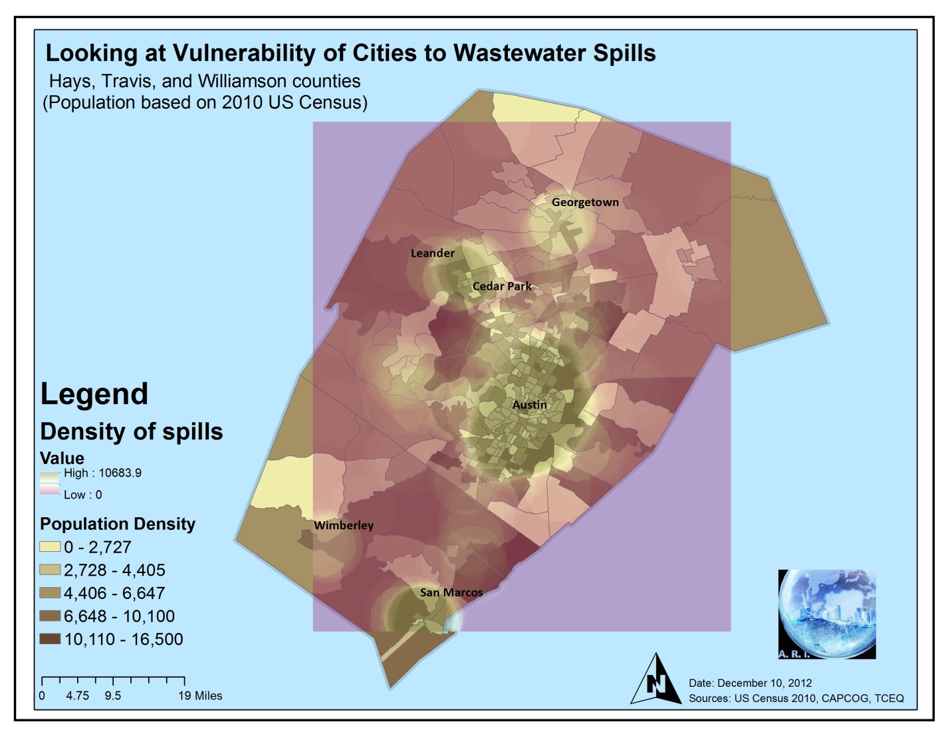
Figure 4. Wastewater Spill Density and Population Density in Travis, Hays, and Williamson

4. CONCLUSIONS
We hope this project’s findings can aid GEAA in their mission to improve aquifer health and expand public awareness of wastewater spills. Considering our spill data only covers spills of 500 gallons or more we feel the statistics are quite shocking. There were a total of 166 spills within the RZ and CZ throughout all three counties, which only make up about 30% of the total spills. This is especially interesting because so many spills occurred within the City of Austin, where many legal battles have and do occur concerning water quality and environmental health.
Perhaps the significant amount of data loss due to lack of spatial information can help make the case for stronger or more accurate regulations regarding wastewater spills. There may also be a case for increased education and preventative maintenance in growing cities, because the most common cause of wastewater spills was due to a blockage of some sort. The second reason, damaged pipe, may also be prevented with more careful monitoring and management.
If nothing else this project has increased our team’s comprehension and concern for Edwards Aquifer and its inhabitants. This data only represents a small portion of a larger picture, and seen in conjunction with other sources such as GeoTex’s project from last spring, can create a very realistic and frightening look at the effects of increased development in ecologically sensitive areas. We can only hope our contribution through this project and its results provides a stronger backbone for organizations and individuals to continue the fight for clean water and a healthy environment.

5. REFERENCES

CAPCOG. 2011. Williamson State of the County 2011. Capital Area Council of Governments, Austin, TX. http://www.capcog.org/documents/ced/State_of_the_County_City/State_of_the_County_-_Williamson_Print_FINAL.pdf. Last accessed 8 December 2012.

GeoTex. 2012. Final Report. GeoTex Environmental Solutions, San Marcos, TX. http://geosites.evans.txstate.edu/g4427/S12/GEAA/FinalReport-GEO4427.pdf. Last accessed 8 December 2012.
APPENDIX I. MAPS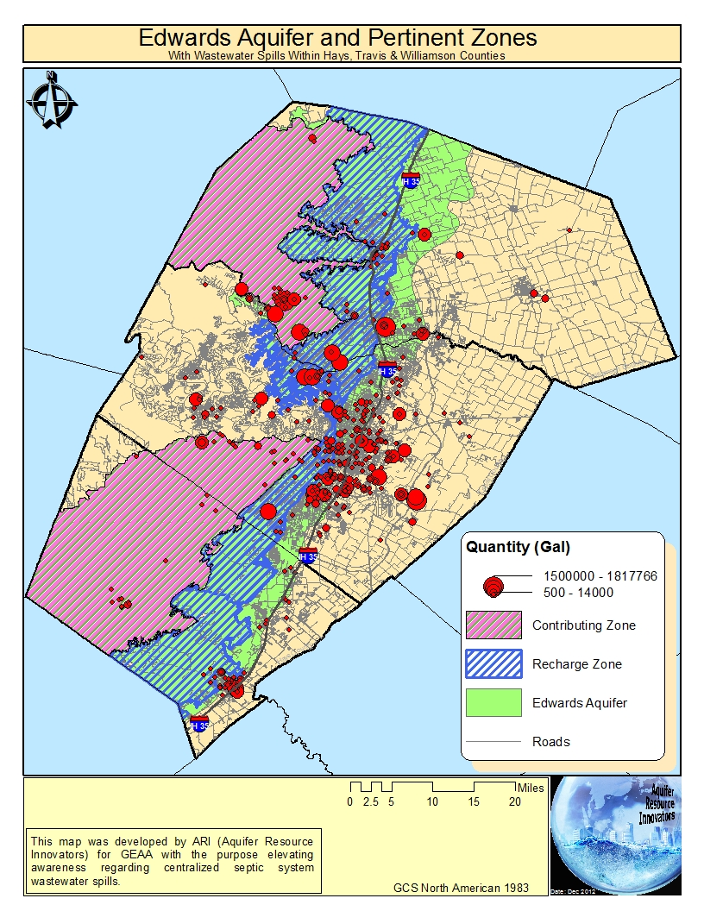
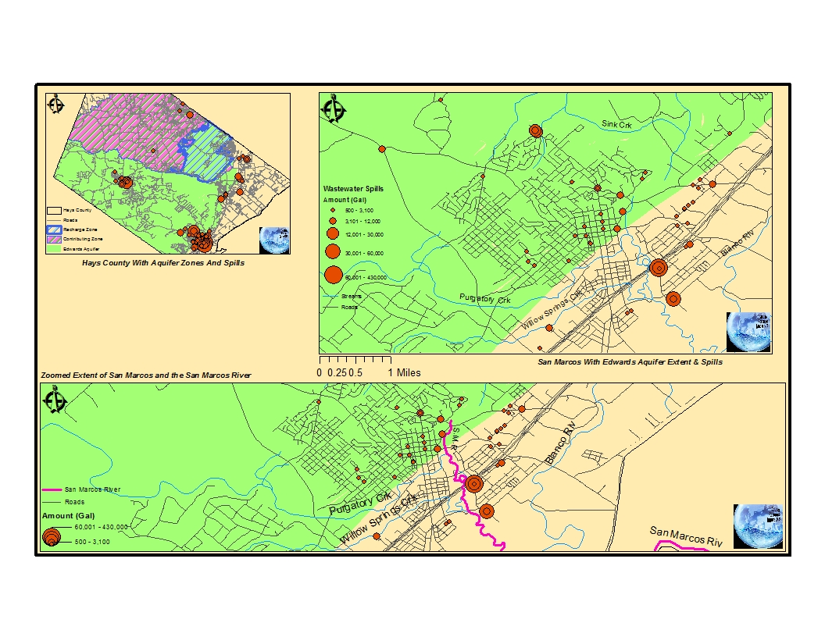
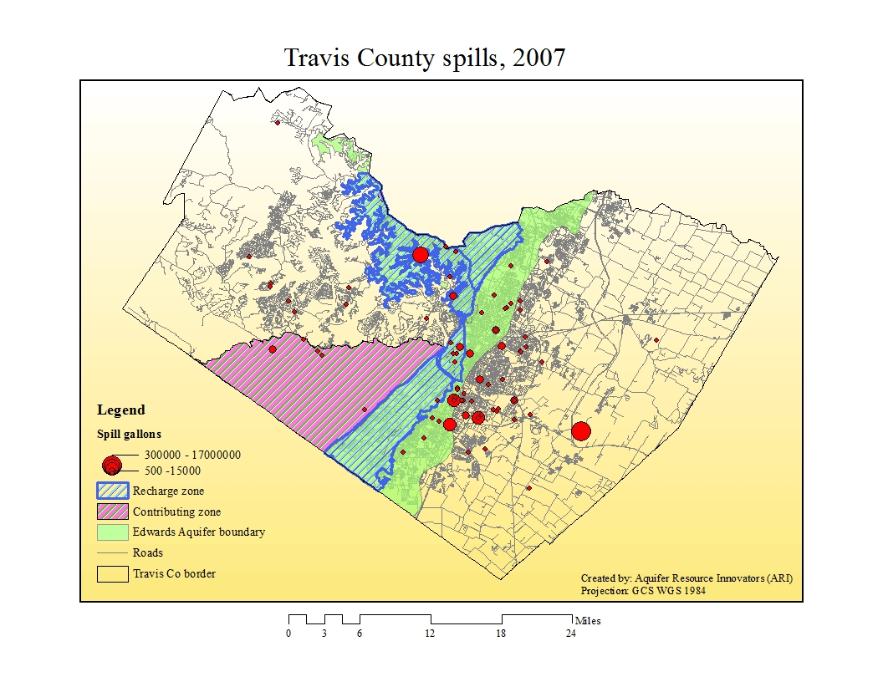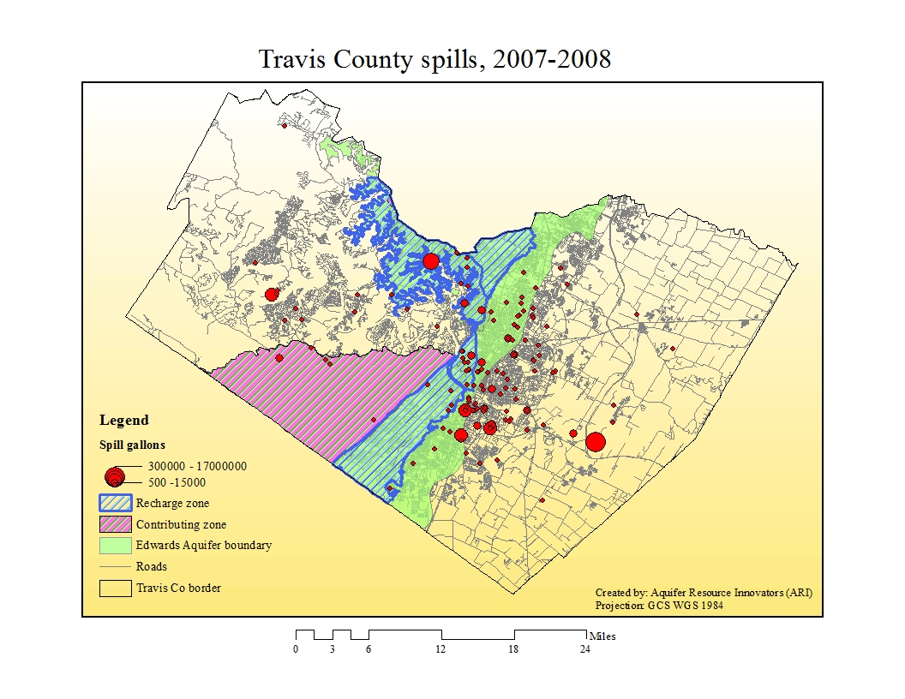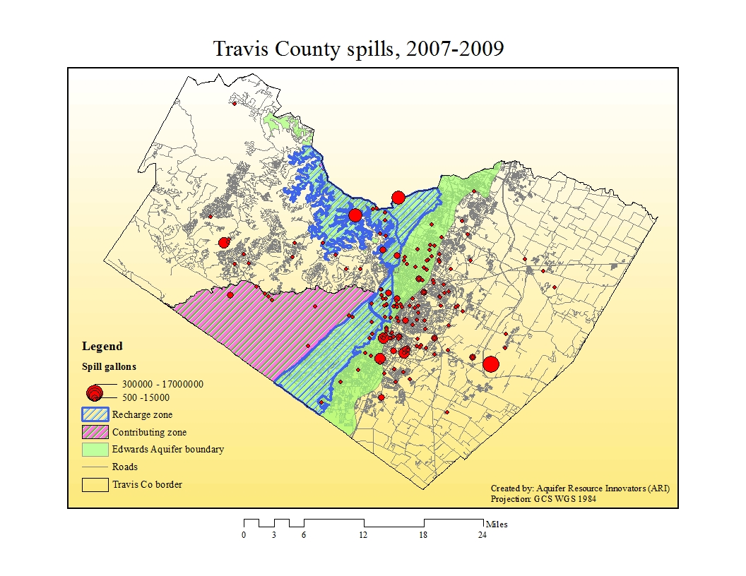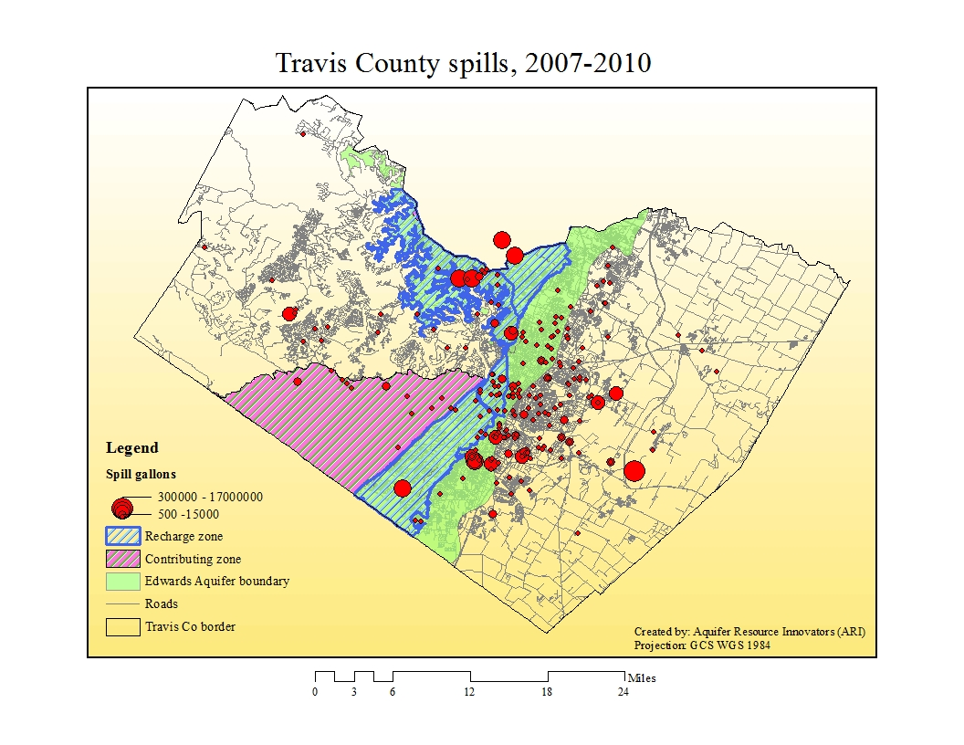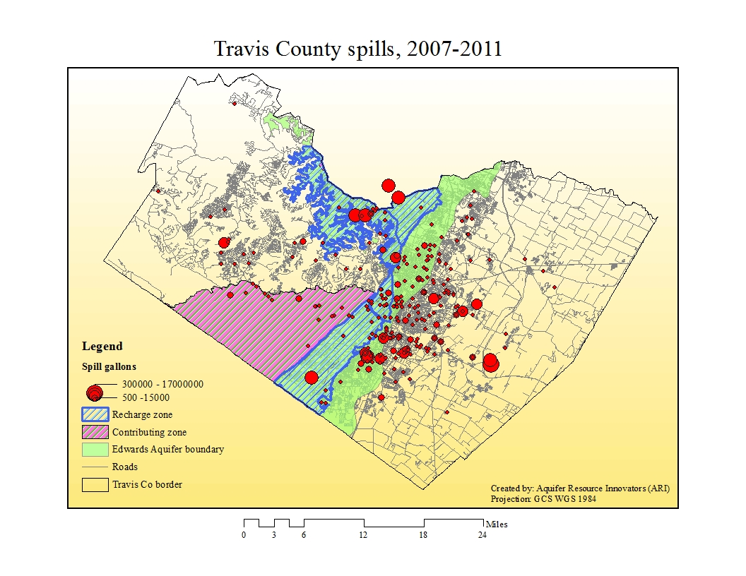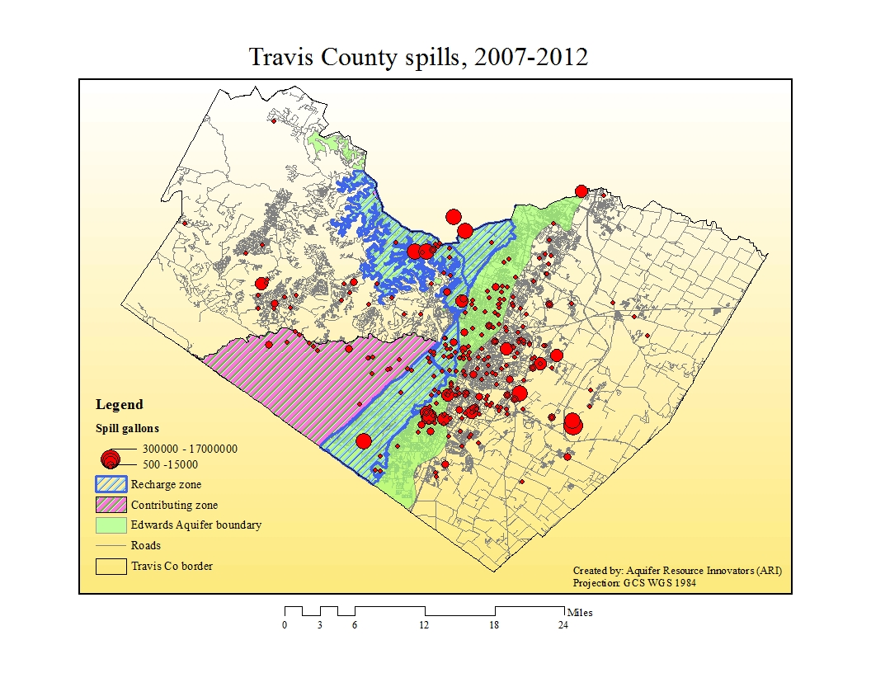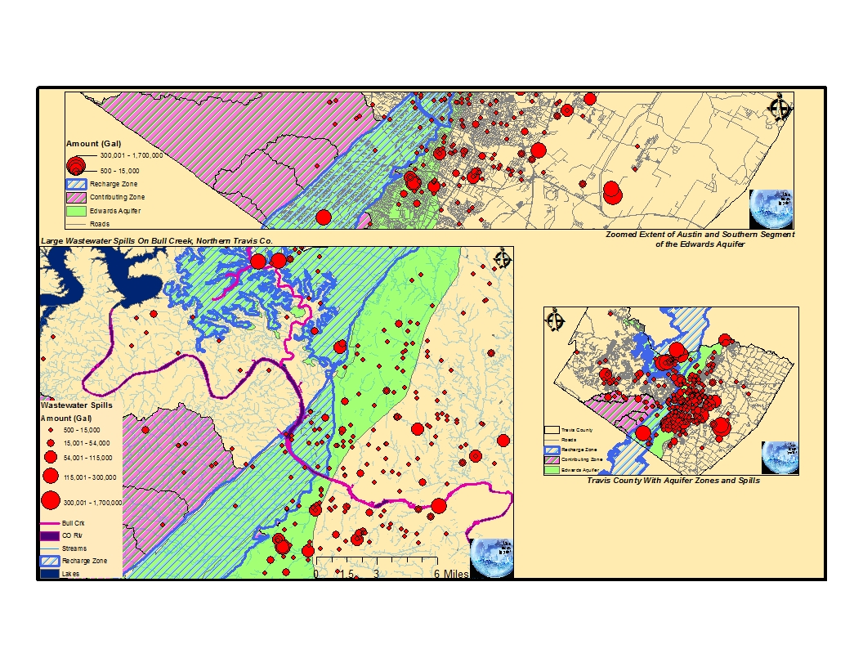
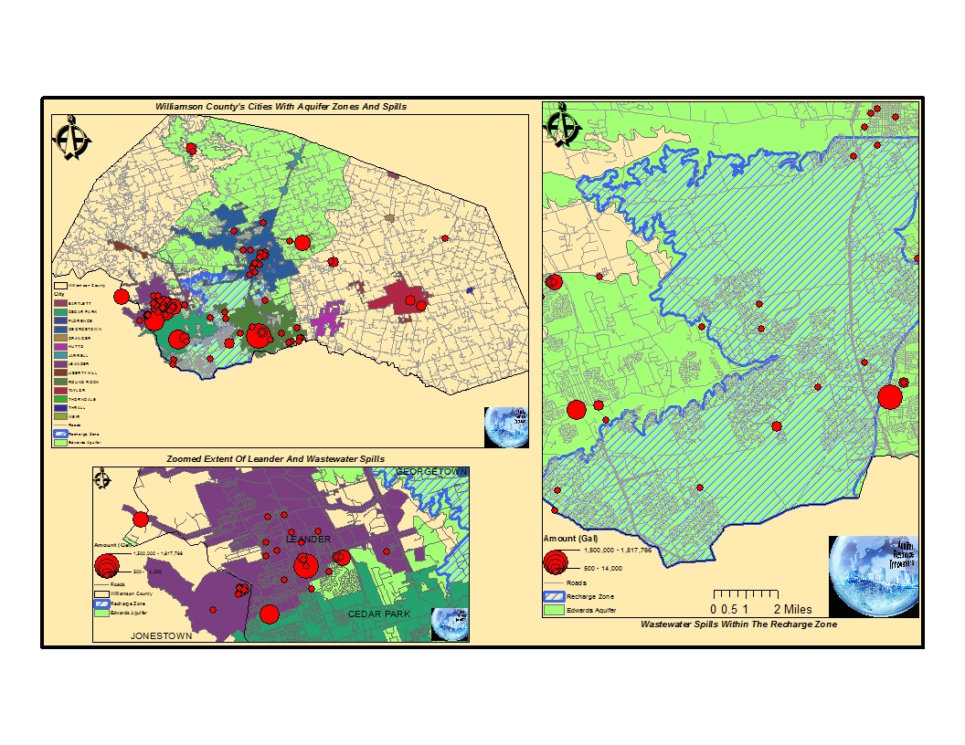
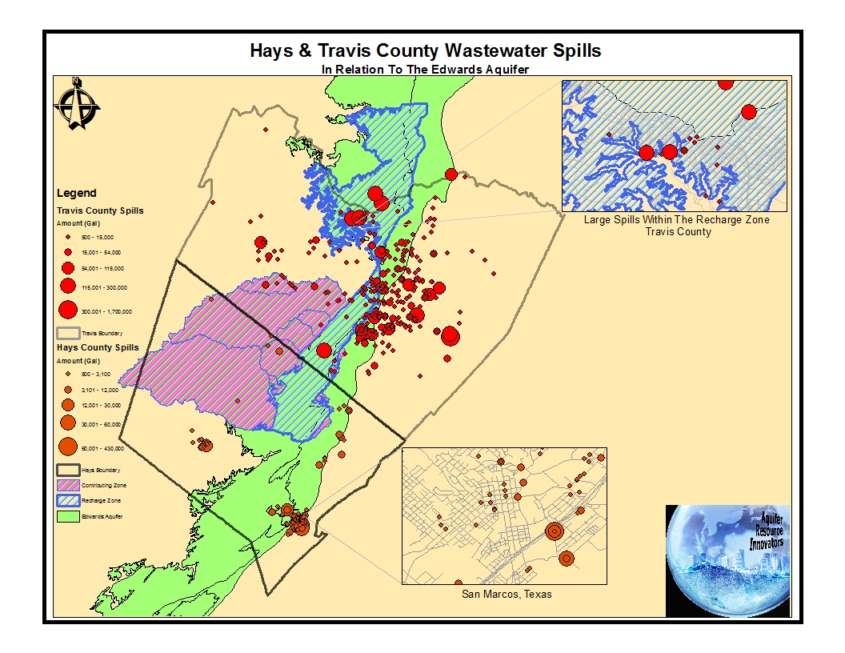

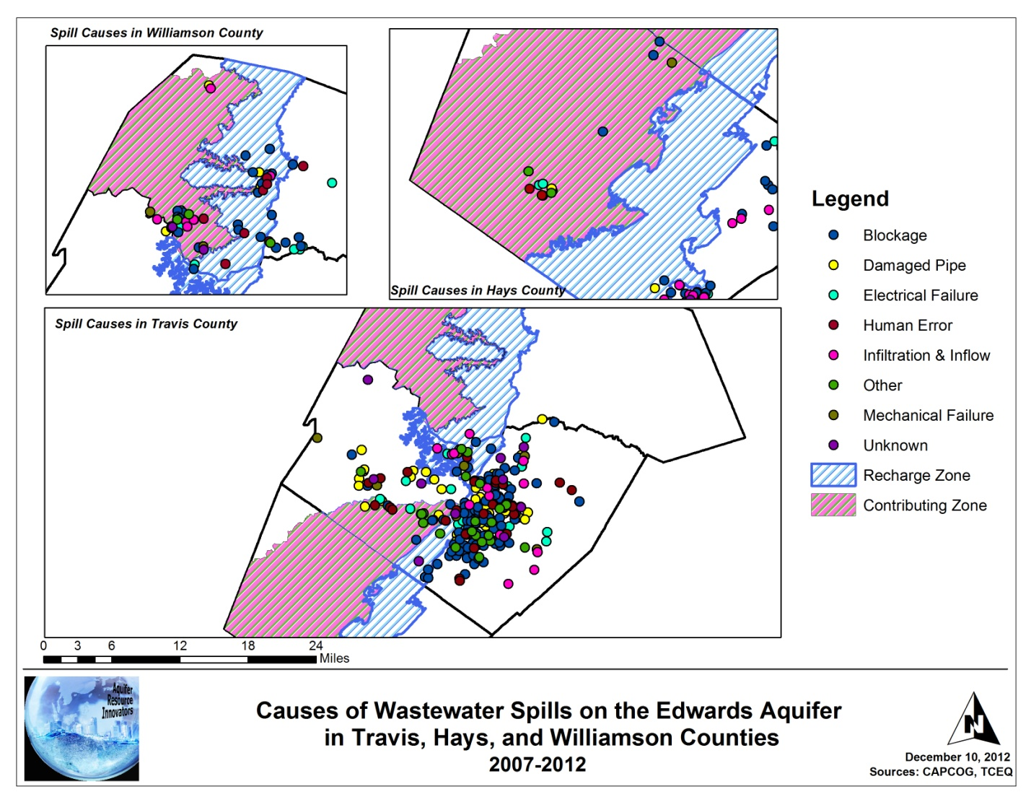
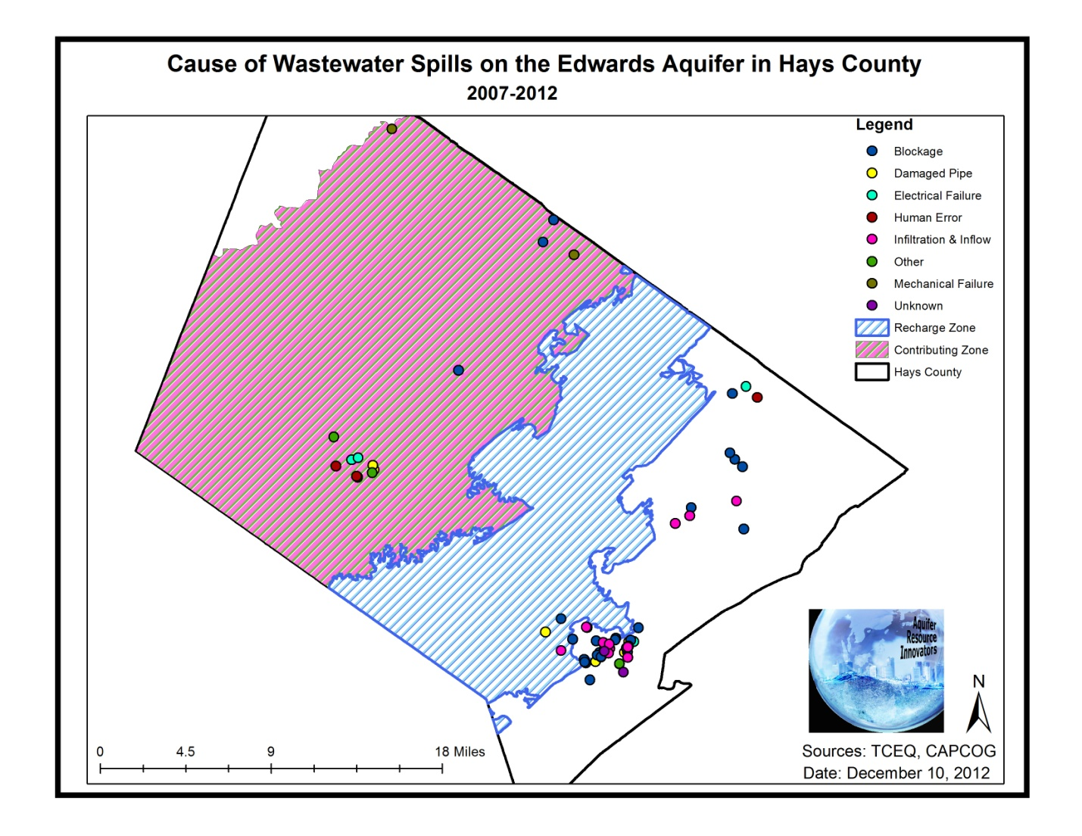
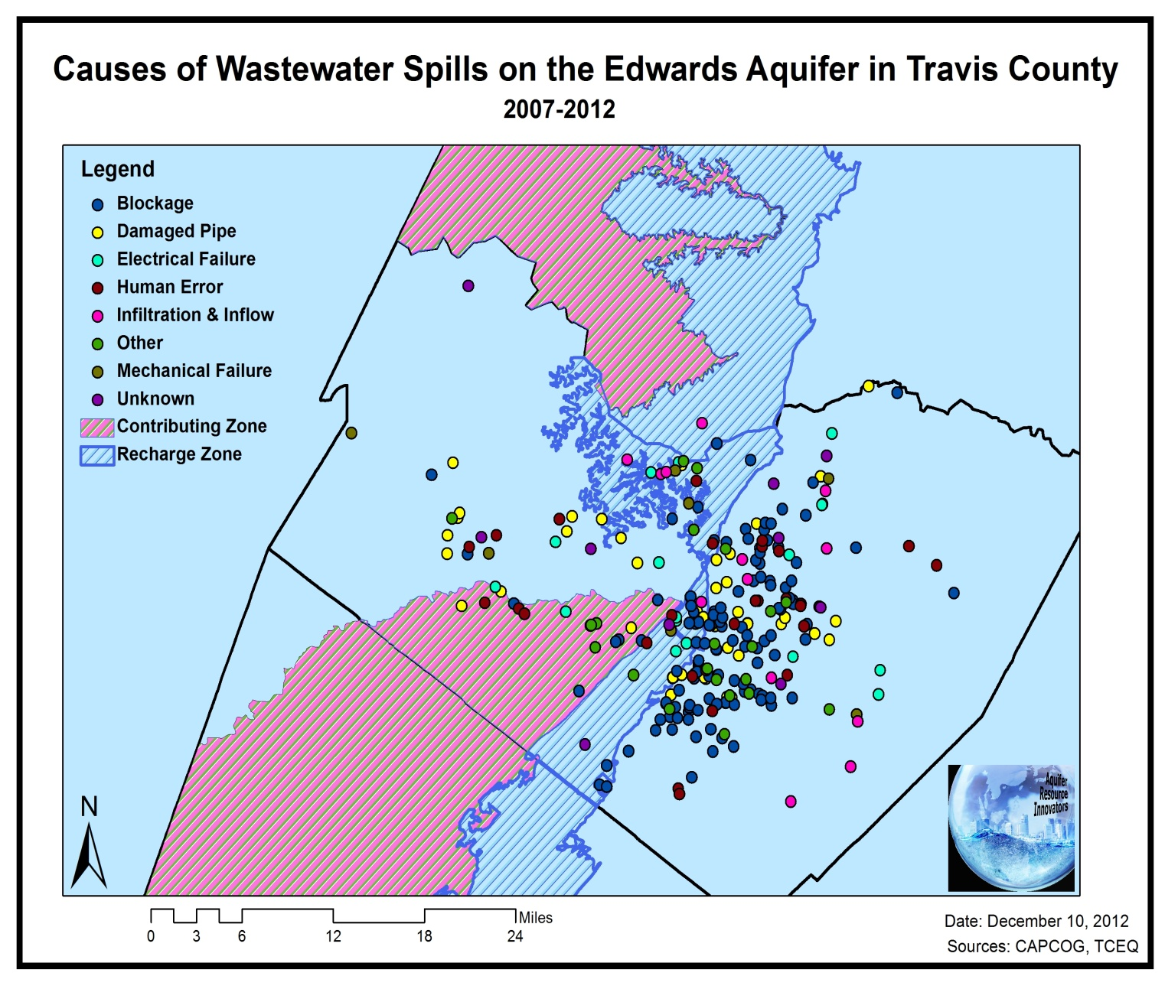
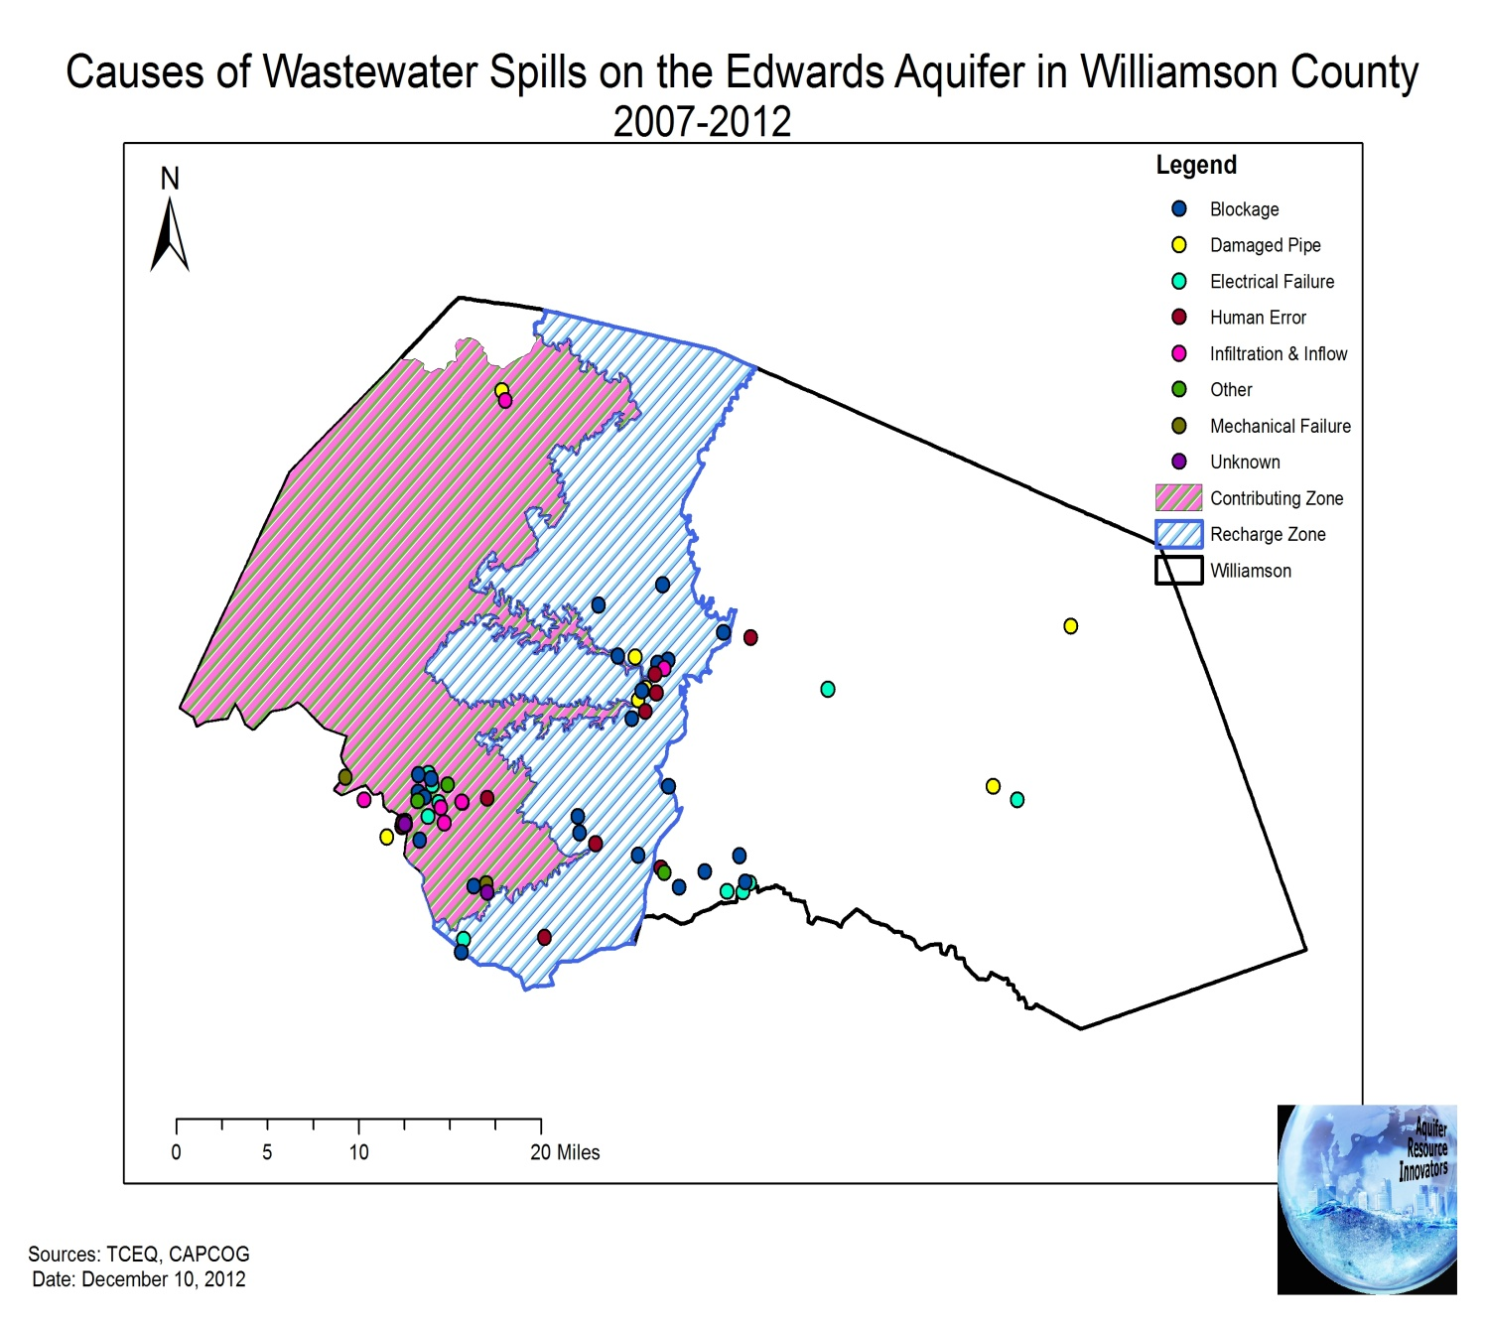
APPENDIX II. METADATA
1. TravHaysWill
Identification_Information:
Citation:
Citation_Information:
Originator: US Census Bureau
Title: TravHaysWill.shp
Geospatial_Data_Presentation_Form: vector digital data
Other_Citation_Details: This data was downloaded through CAPCOG, and the three counties (Travis, Hays, and Williamson) were clipped together.
Description:
Abstract: Polygon layer delineating Travis, Hays, and Williamson counties
Purpose: This layer depicts the Travis, Hays, and Williamson counties grouped together
Status:
Maintenance_and_Update_Frequency: None planned

Spatial_Domain:
Bounding_Coordinates:
West_Bounding_Coordinate: -98.297600
East_Bounding_Coordinate: -97.155219
North_Bounding_Coordinate: 30.906188
South_Bounding_Coordinate: 29.752444
Point_of_Contact:
Contact_Information:
Contact_Person_Primary:
Contact_Person: Katie Steele – GIS Analyst
ks1685@txstate.edu
Contact_Organization_Primary:
Contact_Organization: Aquifer Resource Innovators

Spatial_Data_Organization_Information:
Direct_Spatial_Reference_Method: Vector
Entity_and_Attribute_Information:
Detailed_Description:
Attribute:
Attribute_Label: COUNTYFP10
Attribute_Definition: County number
Attribute_Definition_Source: US Census 2010
Attribute:
Attribute_Label: NAMELSAD10
Attribute_Definition: This is the name of each county.
Attribute_Definition_Source: US Census 2010
Metadata_Reference_Information:
Metadata_Date: 20121126
2. AllWasteSpills

Identification_Information:
Citation:
Citation_Information:
Originator:
Aquifer Resource Innovators
Eric Schroeder (ed.)
Katie Steele (ed.)
Kevin Taylor (ed.)
Katie Tritsch (comp.)
Title: AllWasteSpills.shp
Geospatial_Data_Presentation_Form: vector digital data
Description:
Abstract: Point layer showing locations of wastewater spills in Williamson, Travis, and Hays counties between 2007-2012
Purpose: This layer was created for the Greater Edwards Aquifer Alliance to depict wastewater spills within Williamson, Travis, and Hays counties
Time_Period_of_Content:
Time_Period_Information:
Range_of_Dates/Times:
Beginning_Date: 2007
Ending_Date: 2012
Status:
Maintenance_and_Update_Frequency: None planned

Spatial_Domain:
Bounding_Coordinates:
West_Bounding_Coordinate: -98.675896
East_Bounding_Coordinate: -97.342177
North_Bounding_Coordinate: 30.841923
South_Bounding_Coordinate: 29.863398
Use_Constraints: This data has been created by Texas State University GIS students for the purpose of investigating wastewater spills on the Edwards Aquifer recharge and contributing zones for an assignment. As of 12/10/12, the GIS students are no longer in the course.

Data_Quality_Information:
Attribute_Accuracy:
Attribute_Accuracy_Report: 98% of the spills that were geocoded were an exact match.
Lineage:
Source_Information:
Source_Contribution: Aquifer Resource Innovators obtained wastewater spill data in table form from TCEQ Region 11. We (ARI) removed all "null" values from the data table, organized the table to contain location, spill cause, and action taken to remedy the spill in Travis, Hays, and Williamson counties. Then, we geocoded the events listed in this data table.

Spatial_Data_Organization_Information:
Direct_Spatial_Reference_Method: Vector
Point_and_Vector_Object_Information:
SDTS_Terms_Description:
Point_and_Vector_Object_Count: 536

Spatial_Reference_Information:
Horizontal_Coordinate_System_Definition:
Planar:
Map_Projection:
Map_Projection_Name: GCS_North_American_1983
Geodetic_Model:
Horizontal_Datum_Name: D_North_American_1983
Entity_and_Attribute_Information:
Detailed_Description:
Entity_Type:
Entity_Type_Label: TriCountySpills.shp
Attribute:
Attribute_Label: Match_addr
Attribute_Definition: The address of the wastewater spill
Attribute_Definition_Source: Texas Commission of Environmental Quality (TCEQ)
Attribute:
Attribute_Label: INC_NUM
Attribute_Definition: This is the incident number assigned to the wastewater spill by TCEQ.
Attribute_Definition_Source: Texas Commission on Environmental Quality (TCEQ)
Attribute:
Attribute_Label: Spillcause
Attribute_Definition: Cause of wastewater spills in Williamson, Travis, and Hays counties
Attribute_Definition_Source: Texas Commission on Environmental Quality (TCEQ)
Attribute:
Attribute_Label: AMT_GALS
Attribute_Definition: This is the amount of wastewater spilled, measured in gallons
Attribute_Definition_Source: Texas Commission on Environmental Quality (TCEQ)
Attribute:
Attribute_Label: Action
Attribute_Definition: This is the action that was taken to address and remedy the wastewater spill
Attribute_Definition_Source: Texas Commission on Environmental Quality (TCEQ)
Attribute:
Attribute_Label: ST_DT
Attribute_Definition: This is the date that the wastewater spill began.
Attribute_Definition_Source: Texas Commission on Environmental Quality (TCEQ)
Attribute:
Attribute_Label: END_DT
Attribute_Definition: This is the date that the wastewater ceased from spilling.
Attribute_Definition_Source: Texas Commission on Environmental Quality (TCEQ)

Metadata_Reference_Information:
Metadata_Date: 20121119
Metadata_Contact:
Contact_Information:
Contact_Person_Primary:
Contact_Person:
Katie Tritsch - Project Manager
kt1205@txstate.edu
Contact_Organization_Primary:
Contact_Organization: Aquifer Resource Innovators
Metadata_Standard_Name: FGDC Content Standard for Digital Geospatial Metadata
Metadata_Standard_Version: FGDC-STD-001-1998

APPENDIX III. TEAM CONTRIBUTION
Katie Tritsch –
Team coordinator
Report formatting
Data processing
Statistics
Budge and timetable
Travis sequential maps
Manifold
Eric Schroeder –
Graphic design
Webdeveloper
Literature review
Data processing
Spill causes data
Katie Steele –
Data processing
Data analysis (vulnerability analysis)
Spill causes maps and data
Metadata
Presentation designer
Kevin Taylor –
Geocoding
Manifold
Google Earth
Spill location and volume maps
Poster design
Data processing

